Test Plan – Email Classification System
1. Objective of Testing
The main objective of testing is to ensure that the email classification system:
- Correctly classifies emails into categories such as Spam, Complaint, Important, and Normal
- Accurately processes incoming emails from the mail server
- Ensures reliable communication between user and admin modules
- Works efficiently without errors under different conditions
2. Scope (Modules/Features to be Tested)
The following modules/features will be tested:
a) Email Fetching Module
- Fetch emails from Gmail using IMAP
- Handle connection errors and authentication
b) Email Classification Module
- Classify emails into:
  - Spam
  - Complaint
  - Important
- Validate accuracy of classification logic
c) Admin Panel Module
- View complaint emails
- Reply to users
- Ensure correct sender/receiver handling
d) User Interaction Module
- Email marking (seen/unseen)
- Proper handling of responses
e) Database / Storage (if used)
- Store classified emails
- Retrieve data correctly

3. Types of Testing to be Performed
a) Unit Testing
- Test individual functions/modules:
  - Email fetching function
  - Classification logic
  - Reply handling
b) Integration Testing
- Test interaction between modules:
  - Email fetching + classification
  - Classification + admin panel
- Ensure data flows correctly between components
c) System Testing
- Test the entire system as a whole
- Verify end-to-end functionality:
  - Fetch → Classify → Store → Admin Response
d) Functional Testing
- Verify system meets requirements:
  - Correct classification
  - Proper email routing
e) Error Handling Testing
- Invalid login credentials
- Network failures
- Incorrect email formats
4. Tools (if any)
- Programming Language: Python
- Libraries Used:
  - imaplib – for email fetching
  - email – for parsing emails
  - re – for pattern matching
- Testing Tools:
  - Manual testing via console
  - (Optional) PyTest for automated testing
5. Entry and Exit Criteria
Entry Criteria
Testing will begin when:
- All modules are implemented
- Code is compiled without errors
- Required test data (emails) is available
Exit Criteria
Testing will be completed when:
- All test cases are executed successfully
- No critical bugs remain
- System meets expected accuracy and performance
- Admin and user workflows function correctly

Module: Email Processing Module
Main function used:
- process_email() from
This module:
- Cleans text
- Detects spam
- Classifies using ML
- Assigns priority
- Generates response
- Stores in DB
- Sends email

TC ID | Description | Input | Expected Output
01 | Spam detection | "You won a lottery" | Category = Spam
02 | Complaint email | "My product is damaged" | Category = Complaint, Priority = High
03 | Request email | "I want refund" | Category = Request, Priority = Medium
04 | Inquiry email | "What are your pricing plans?" | Category = Inquiry, Priority = Low
05 | Normal email | "Hello how are you" | Category = Inquiry/Normal
06 | Empty input | "" | Should handle safely
07 | Special characters | "!!! Win $$$ now !!!" | Spam
08 | Mixed content | "I want refund but service is bad" | Complaint (priority handling)

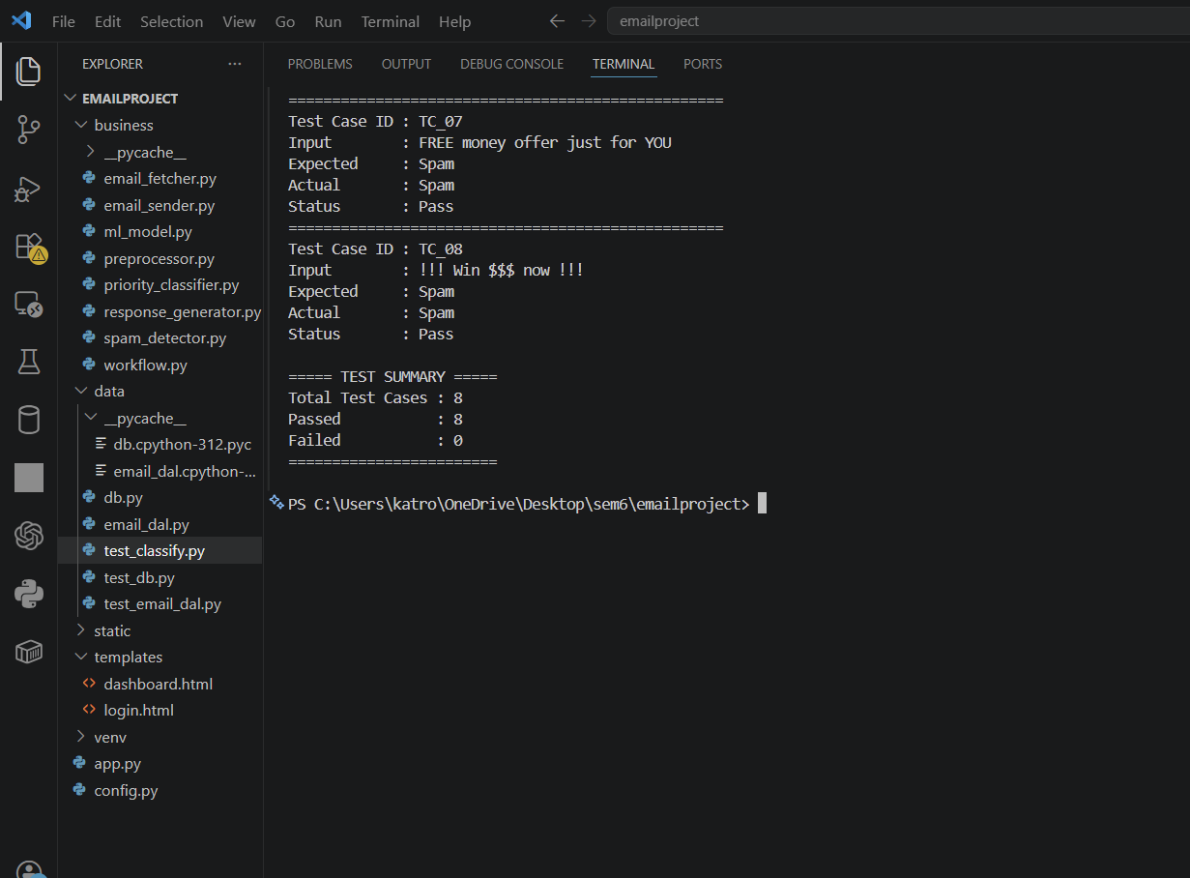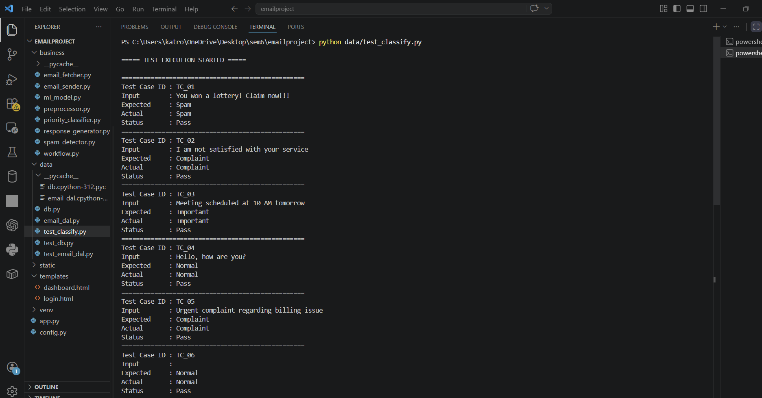

(5) What Is Actually Tested (Important)
From your real system:
Spam Detection
detect_spam(text)

ML Classification
predict_category(text)

Priority Assignment
assign_priority(category)

Response Generation
generate_response(category, text)

BUG 1: False Spam Detection (Keyword-Based Issue)
Bug ID: BUG_01
Description:
The spam detection module incorrectly classifies legitimate emails as spam due to simple keyword matching.
code checks:
if word in text:
return True

- Run test case:
"Meeting about free resources tomorrow"
- Execute:
python data/test_classify.py

Expected Result:
Category = Important
Actual Result:
Category = Spam

BUG 2: Empty Input Not Properly Handled
Bug ID: BUG_02
Description:
The system processes empty input and treats it as a normal email instead of invalid input.
In process_email()
No validation for empty input.

Steps to Reproduce:
- Run:
process_email("")

Expected Result:
Should return:
Error / Invalid Input

Actual Result:
System processes it and stores in database.

Severity:
Low

BUG 3: Email Sending Parameter Error
Bug ID: BUG_03
Description:
Incorrect function call for sending email replies.
In process_email():
send_email(sender_email, response)
But actual function is:
send_email(to_email, subject, body)
from

Steps to Reproduce:
- Trigger reply (non-complaint email)
- Run system

Expected Result:
Email sent successfully

Actual Result:
Error due to missing parameters

Severity:
High

Bug ID: BUG_04
Description:
ML model misclassification due to limited training data.
Model defined in

Steps to Reproduce:
Input:
"I am unhappy but also need refund"

Expected Result:
Complaint

Actual Result:
Request

Severity:
Medium

